Day33 MongoDB Use Case.

Create a Spring Boot Micro-service using MongoDB for ARS application.

Microservice vs Monolith.

ARS-v2 – Single Monolith application which contains all the modules in a Single Spring Boot project.

ARS-v3 – Microservice Architecture (Discovery Server, API Gateway, Config Server, Other micro-service)

JDK

DB (MS-SQL/My-SQL, MongoDB)

IDE (STS/VS Code/Eclipse/Intellij)

Booking micro-service

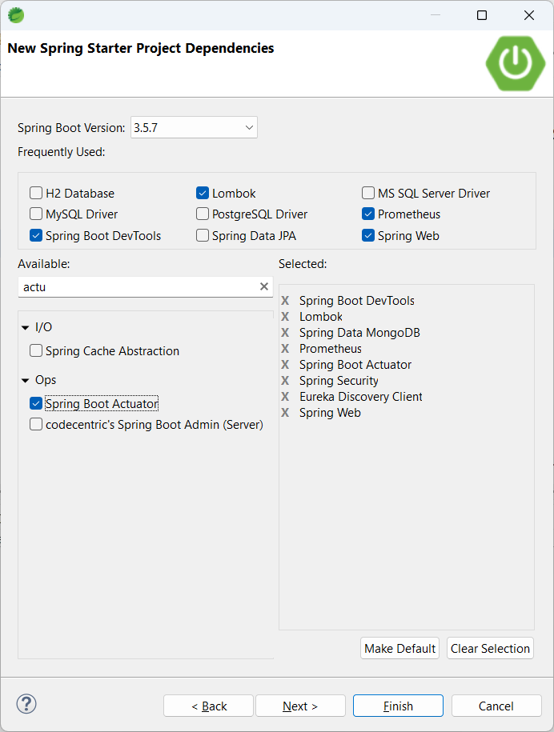

DTO vs Model/Entity

DTO is mainly used for Data transfer purpose only. Not persisted data. (Used only for client to server or service to service communication)

Model content is persisted.